The Outsiders: Facebook Project Name:
DUE TUESDAY NOVEMBER 15TH
Introduction
The Outsiders by S.E. Hinton takes place during the 1960s in Tulsa, Oklahoma. Life for a teenager was much different 50 years ago than it is today and many of those differences were evident in the book. Do you think the story would have been different if the setting has been 2011 instead of the 60s? For example…
Why are Johnny and Ponyboy cut off from the rest of the group while at the church in Windrixville? Why must Soda rely on a handwritten note to communicate with Johnny? What does Dally do when he robs the store after Johnny’s death?
Directions
Pretend that The Outsiders took place in the 21st century. This means that, like most teenagers, all of the characters in the book would be carrying cell phones. And, like most teenagers, they all have Facebook accounts.
Create a Facebook wall for Johnny, Ponyboy, or Dally. The status updates and replies should accurately reflect the characters’ personalities as well as their relationships with each other. Your status updates should focus on major events in the plot.
You must:
- Choose one of the three main characters
Ponyboy Johnny Dally
- Write FIVE status updates for this character. These updates need to focus on major events in the plot. Status updates should be creative and accurately reflect your character’s personality.

- Choose a variety of characters below to create TWENTY responses to the status updates. Your responses must reflect each character’s personality. Your responses must accurately reflect the characters’ relationships with each other.
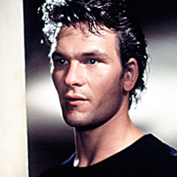
Ponyboy Johnny Dally Darry
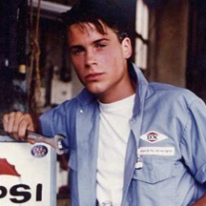
Soda pop Steve Two-Bit Tim Shepard
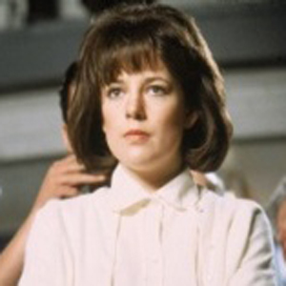
Bob Randy Cherry Marcia
Jerry
We will be working on this project Wednesday and Thursday during period 6. Please come to class those days prepared to create your Facebook pages. That means that you need to plan out your status updates and replies ahead of time!
The Outsiders Facebook Rubric
Status updates refer to major events in the plot/plot events are in chronological order | 35
Status updates and replies reflect characters’ personalities and relationships | 35
Minimum of five status updates and twenty replies | 10
Proper punctuation | 10
Neatness/proper formatting | 10
 | Total:

